Productr Report

Report No# SB4-000064 Date : 2020-06-13

Subsidiareis Information

**Owner Name:**

owner3

**Owner Email:**

[owner3@gmail.com](mailto:owner3@gmail.com)

Customer Information

|  |  |  |  |
| --- | --- | --- | --- |
| Customer | Name: | Conner Hand | Phone_number: | +3290710552469 |
| Address: | 37787 Stamm PathOsinskitown, GA 92188-3392 | | |

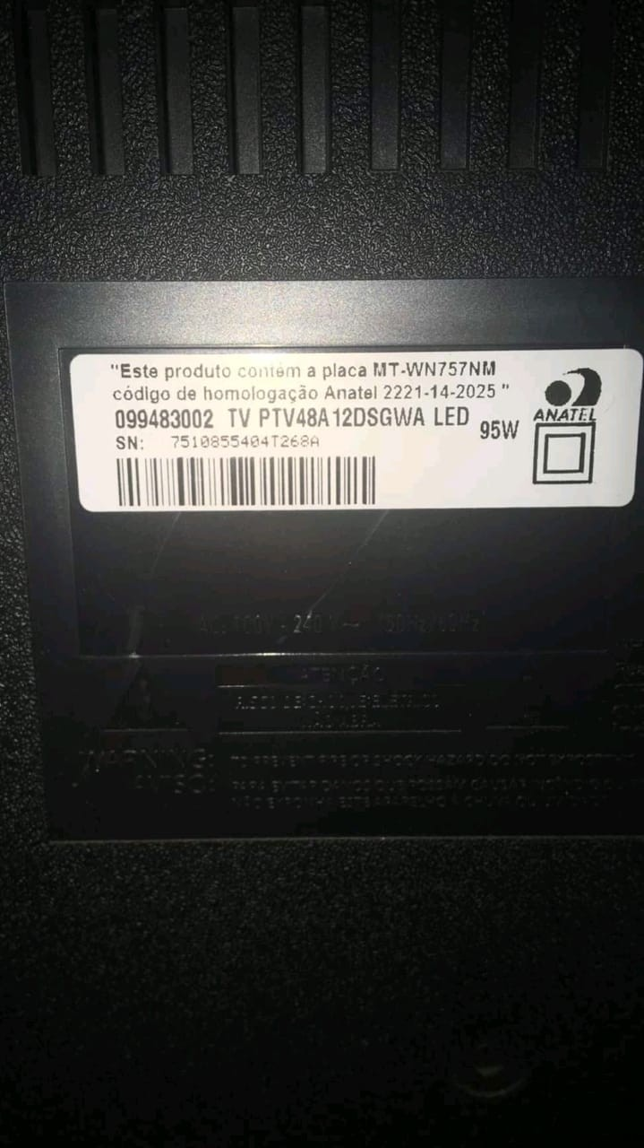Product Information

|  |
| --- |
| **Product Progress:** 0 % |
| **Status:** pending |
| **Image:** |